Name: Fatimah S.
Hello Dr. Gabi,
Here are my findings:
Claim: I prioritize altitude changes because the data below shows as the altitude changes the maintenance events per quarter increases constantly. This means the engine on high altitude changes use more fuel, due to changes in the altitude which requires the engine to adjust its power output thereby putting stress on the engine over time. As a result, I recommend that the altitude changes should be tracked very closely to predict engine maintenance needs.

Reference to the data: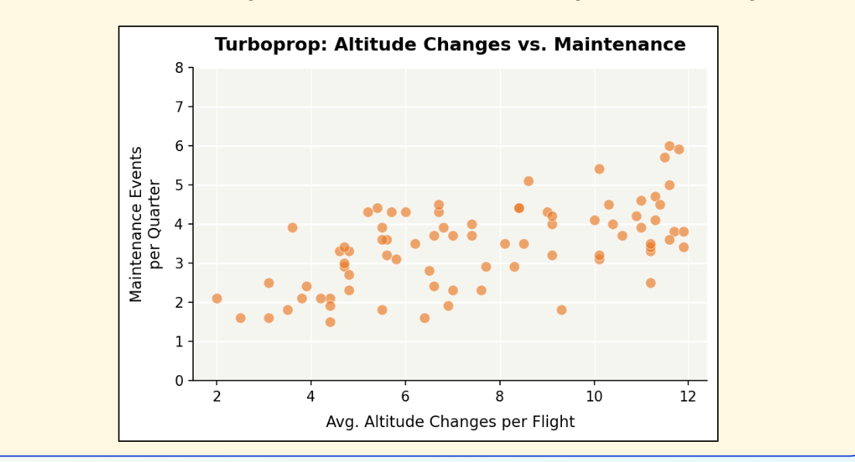
I notice this data has a clear upward pattern. Which is a strong predictor for engine wear on its own.

Carrier’s specific route: This recommendation fits the carrier route because the routes are across mixed terrain and pilots adjust their altitude frequently.

